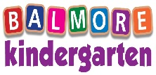

NEWSLETTER: April 2021

[laura@balmorekindergarten.co.uk](mailto:laura@balmorekindergarten.co.uk)

[karen@balmorekindergarten.co.uk](mailto:karen@balmorekindergarten.co.uk)

**Summer Lunch/Snack Menu**

At the end of April, we will be looking at changing to a summer menu for lunch/snacks, if you would like to send in any suggestions or ideas for this you can email Laura or Karen with these



**Children’s Learning Journals**

Please keep up to date with your child’s learning and news via our online journal system. Learning journals are updated on a weekly basis and you can arrange to discuss any matters relating to your child’s learning and development with their keyworker or senior of the department. Feel free to use the “Home Achievements”, this allows you to upload your child’s achievements to celebrate with their friends.

if your child is in the small/big Penguin rooms then their learning journals are all paper copy and are kept in their folder within the room. You can have access to these any time if you arrange time to have a look with your child’s key worker.

If you do not have access to your child’s journal, you can click the link on our nursery website or please do not hesitate to speak with Karen

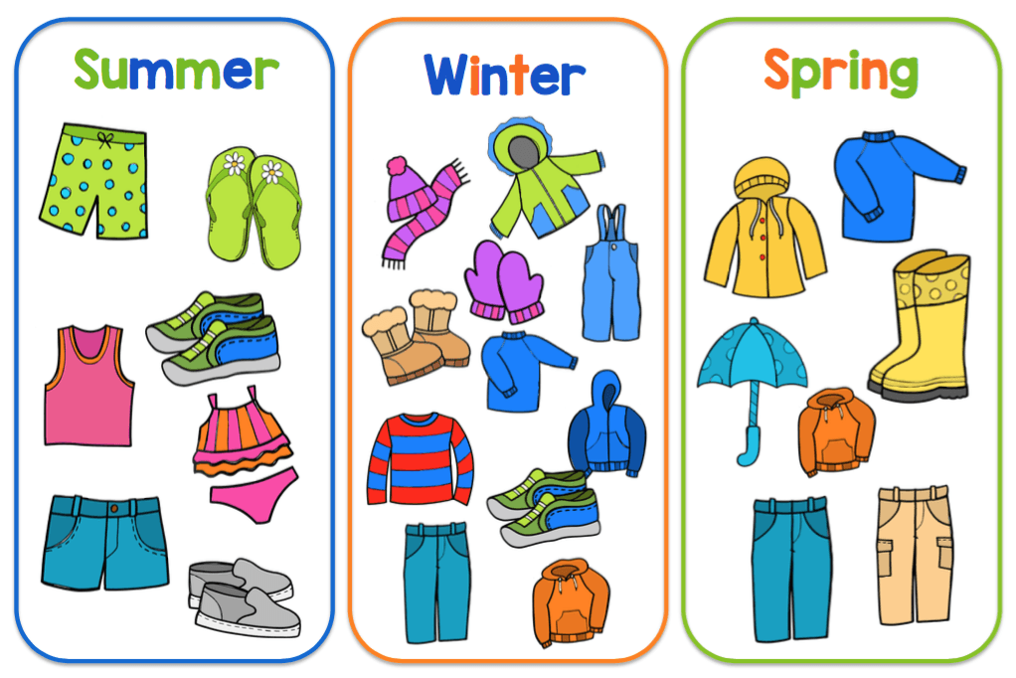

**Nursery Essentials**

A little reminder of what to pack in your child’s nursery bag

* Spare clothing
* Jacket/all in one suit
* Wellies
* Sun Cream/Sun hat



**Dates for your Diary**

National Pet Month

Good Friday – 2nd April

Easter Sunday – 4th April

The Queen’s Birthday – 21st April

St Georges Day – 23rd April

World Penguin Day – 25th April

Friday 16th April we will have a special visit from the Easter Bunny along with a petting zoo, this will be 9am -12pm. If your child does not attend on this day you are more than welcome to bring your child along between 12pm-1pm to see this, we just ask that all parents continue to follow the guidelines in place 😊







**Our Owl Department**

This month the children in the Owl department will be focusing their learning on Springtime, we will be looking at what happens to the environment in Spring, going out and exploring the local area/parks. We will be turning our role play area into a farm shop where the children will learn what type of foods come from the animals. Our learning this month will also include developing our counting skills where we will provide different number games, songs, and outdoor activities to help our children with their numeracy skills.

Story of the Month – Farmyard Hullabaloo

Colour of the Month - Yellow

Rhyme of the month – 5 little ducks



**Our Duckling Department**

This month our little ducklings are looking forward to learning about Spring as we enter this new season. Our garden will be receiving a mud kitchen soon, so please make plans for this and ensure your child has spare clothing (2-3 changes) due to messy play, messy mealtimes, and outdoor play we expect our little ones will need to be changed more than once. We ask you to provide wellies/outdoor footwear. We are excited for the children to explore the environment this way where there will also be able to engage in schematic play. The nursery does have some spare clothing; however, we do ask if your child goes home with nursery clothing if you could wash this and return it please.

Rhyme of the month – Sleeping bunnies

Colour of the month – Yellow

Story of the month – Hop little bunnies

Room Theme – Farm/Spring



Our Big Penguin Department

Throughout the month of April our Penguins will be learning about the rainforest, where they can be found and animals that can be found in the rainforest. We will be exploring bugs, taking part in lots of research using the Ipad, taking part in science experiments including measuring the rain. Our playroom will be focussing on the rainforest theme throughout our areas.

Story of the month – Were roaming in the rainforest

Artist of the month – John Dyer

Colour of the month – Green





**Our Small Penguin Department**

This month our little Penguins are going to be learning about animals/pets, we will be changing our role play area into an animal hospital. We are going to be teaching our children about compassion, respect, build their self-esteem and social skills. They will also learn about the medical equipment used by animal doctors/nurses.

Colour of the month – Green

Story of the month – Mog and the vet

Song of the Month – Baby goes to the vet



**Employee of the Month**

We would like to congratulate Billiejo Taggart, student in our little Penguin department on receiving employee of the month for all her hard work within her department and being very supportive to other departments. Billiejo is very hard-working and is always happy at her work. Well done Billiejo 😊



BALMORE KINDERGARTEN BIRTHDAY’S



|  |  |  |  |
| --- | --- | --- | --- |
| Duckling’s | Owl’s | Small Penguin’s | Big Penguin’s |
| Craig Donnelly – 1st April | Ronan Dalzell – 5th April | Lucy Ambrosini -3rd April | Alexa Pringle – 24th April |
|  | Orla McLaren – 17th April | Ariah Caven – 16th April |  |
|  |  |  |  |
|  |  |  |  |
|  |  |  |  |

