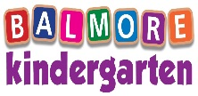

NEWSLETTER: June 2021

[laura@balmorekindergarten.co.uk](mailto:laura@balmorekindergarten.co.uk)

[karen@balmorekindergarten.co.uk](mailto:karen@balmorekindergarten.co.uk)

**Graduation**

This will be held in the nursery on Friday 25th June 2021 10am – 12 noon

This will be a ceremony followed by a party for the children to celebrate together

Unfortunately, due to the current Covid-19 restrictions no parents will be permitted to attend





**Nursery Essentials**

A little reminder of what to pack in your child’s nursery bag

* Spare clothing
* Jacket/all in one suit
* Wellies
* Sun Cream/Sun hat

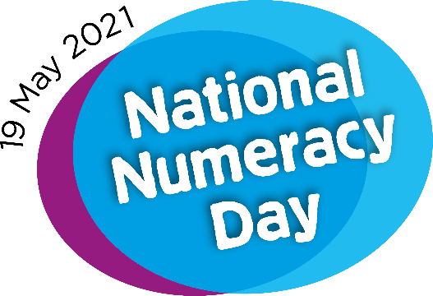

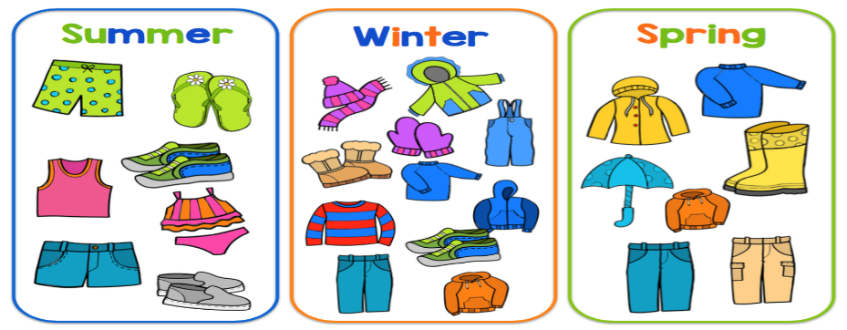

**Dates for your diary**

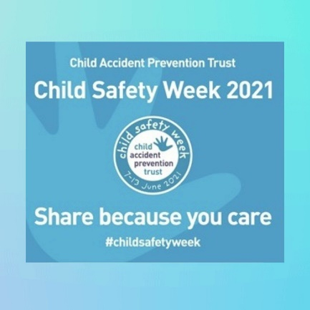****

World bicycle day – Thu 3rd June – Children can bring in their own bikes to nursery

Child safety week – 7th – 11th June

Healthy eating week – 14th – 18th June

Father’s Day – Sun 20th June

Insect week – 21st June – 25th June

World music day – Mon 21st June



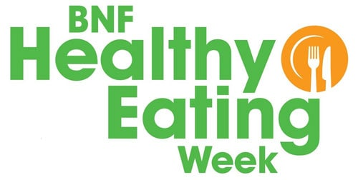

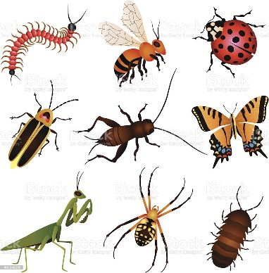

**Our Owl Department**

This month the children in the Owl department will be learning about dinosaurs. We will be learning the names of different dinosaurs, their life cycle, and their habitat. We will be creating fossil’s using different types of materials. We will be going out more local walks to learn a little about ‘road safety’.

Book of the month – Ten little dinosaurs

Song of the month – Dinosaur stomp

Colour of the month – Orange

On the 18th of June, the little owls will be having a dinosaur party, children are welcome to wear dinosaur dress up or masks on this day



**Our Duckling Department**

This month our babies are so excited to focus on a new theme which will be ‘beach’. We will be taking part in lots of water and sand play; it would be helpful if parents would bring in swimsuits/shorts/sun hats for your children.

Song of the month – The sun has got his hat on

Colour of the month - Yellow

Story of the month – That’s not my mermaid

Room Theme – The ‘beach



Our Big Penguin Department

The big Penguins this month will be focussing on their transition into school. They will be practising for their graduation, talking about what to expect when going to school and what they will learn about. They will also discuss how it is a different from nursery. As there is a few children in the big Penguin room that are not going to school this year there will also be learning about healthy eating, and with the summer coming in learning about summer.

Story of the month – Starting school

Song of the month – We’re all in this together

Colour of the month – Red





**Our Small Penguin Department**

This month our little Penguins are looking forward to learning about pirates, sea & ships. Our children will have the opportunity to dress up and explore the role play area which will be a pirate ship the children will create using different materials. They will take part in lots of fun activities which include purposeful and engaging writing, maths and games. The children will build on their counting skills with the gold coins, they will match up the jewels and do some sorting with other resources. The children will have the opportunity to be active using the big parachute for pirate songs and games. They will learn the sounds that pirates make and learn to get into character, learning new vocabulary.

Colour of the month – Red

Story of the month – Pirate’s love underpants

Song of the Month – Pirate song



BALMORE KINDERGARTEN BIRTHDAY’S



|  |  |  |  |
| --- | --- | --- | --- |
| Duckling’s | Owl’s | Small Penguin’s | Big Penguin’s |
| Max Morrison – 8th June (1 year old) | Esme Martin – 7th June (2 years old) | Erin Anderson – 8th June (4 years old) | Freddie Johnstone – 4th June ( 5 years old) |
| Blake Graham – 26th June (1 year old) | Minnie Wainwright – 16th June (3 years old) | Luke Scally – 8th June (4 years old) | Lucas Lehmann – 19th June (5 years old) |
|  |  |  |  |

