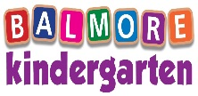

NEWSLETTER: October 2021

[laura@balmorekindergarten.co.uk](mailto:laura@balmorekindergarten.co.uk)

emma@balmorekindergarten.co.uk

**Dates for your diary**

For Halloween, this year we will be having a Halloween week due to our current restrictions this will be Monday 25th October – Friday 29th October

Throughout this week children will take part in different Halloween activities and party games we will ensure none of our children miss out in any of this fun, unfortunately we cannot have our normal parties this year however we will make sure all our children enjoy Halloween just as much and they are more than welcome to dress up every day if they wish.

We will have a Halloween Bake Sale on Thursday 28th of October, all home baking is welcomed can I ask that all baking is Nut free and noted if dairy or eggs have been used.



Please look out for your children’s own design Christmas cards coming home over the next couple of week’s, we plan to have these all done and home by the 15th of October and must be returned by Friday the 29th.

**Winter Menu**

Over the next couple of weeks we will be changing our lunch/snack menu’s over to our winter menu as the winter is slowly creeping in we will be providing some nice hot home cooked lunches for all our children still ensuring we are following the Setting the table food nutritional guidance document and food standards as usual

Our new winter menu will be up on our website for you to have a look at which is:

[www.balmorekindergarten.co.uk](http://www.balmorekindergarten.co.uk)

**Our Owl Department**

This month in the Owl department children will be continuing to further their knowledge on shapes, numbers, and colours through lots of Halloween and Autumn experiences. They will work together to create a haunted house area with a scarecrow. The children will also have the opportunity to go on Nature Hunts.

Song of the Month – 5 little pumpkins

Story of the Month – 5 little pumpkins

Colour of the month – Orange

**We would like to give a warm welcome to Amanda Allison who has joined our Owl’s department as a Qualified Staff member.**



**Our Duckling Department**

This month the Duckling department will be enjoying imaginative play, there will be lots of role play taking part within the Halloween home corner. The children will also enjoy making Halloween treats and decorations to display within their room.

Song of the month – 5 little pumpkins

Colours of the month – Purple

Book of the month – That’s not my Bat





**Our Big Penguin’s**

Throughout October we will be looking at the changing season and exploring why it is getting darker earlier. We will be exploring different hibernating animals, Road saftey and how to stay safe through winter and what outdoor clothing we should be wearing as it gets colder and wetter.

Story of the Month – Room on the Broom

Colour of the Month – Brown

Song of the Month – I’m a little hedgehog

All of our Penguin children will start to learn the christmas nativity songs, Children’s parts are being allocated this week for rehearsals to begin.

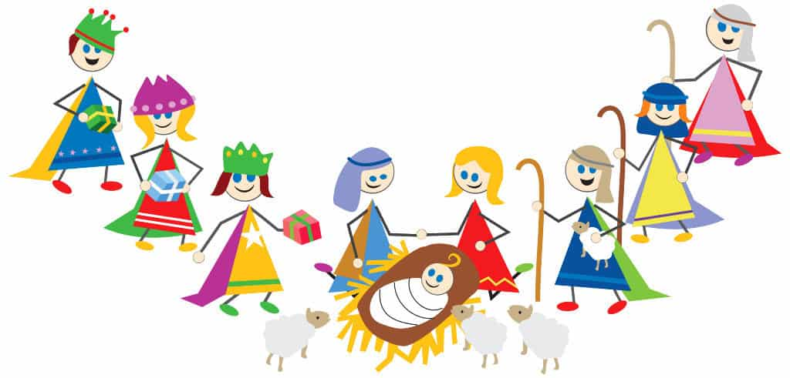

**Our Penguin Department**

**Our Little Penguin’s**

Throughout this month we are going to be exploring a variety of Halloween learning experiences, the children have chosen to have a witch kitchen within the role play area, giving them the opportunity to make special Halloween treats. Children will have the opportunity to dress up and immerse in imaginative play.

Story of the month – Room on the Broom

Colour of the month – Orange

All of our Penguin children will start to learn the christmas nativity songs, Children’s parts are being allocated this week for rehearsals to begin.

**A Big Happy Birthday To…**

**Duckling Birthdays**  **Owl Birthdays**

Beau Moses – 7th Oct

Cody Davis – 27th Oct Miller Logan – 12th Oct (2 years old)

Ciara Tunn – 31st Oct Harper Payton – 23rd Oct

**Penguins Birthdays**

Pixie Park – 12th Oct

