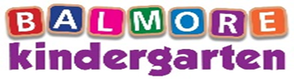NEWSLETTER…Summer 2021
laura@balmorekindergarten.co.uk
karen@balmorekindergarten.co.uk
Learning Journals

As we have now approached the summer period and it has been a busy time, our girls within each department will bring any children’s learning journals up to date that have fell a little behind recently. Our summer stories will be uploaded throughout July until our new term begins 16th August. If you have not yet got access to your child’s learning journal, please contact a member of staff within your child’s room.

Reminder that the 3-5 children’s learning journals are not online and if you would like to see this then speak to a member of staff within the room to organise this.

Parent Contact Form  Can I remind all parents how important it is that we have your up to date contact details and any changes to phone numbers/addresses etc the office should be updated. If you have not been given a parent contact form, can you please ask a staff member within your child’s room | Staff Training this month  - Sat 3rd July – Child Protection and Infection Control  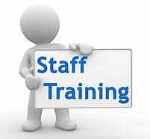
Summer Wear

Due to the warm weather coming, can we ask all parents to provide their child with sun cream, sun hats and appropriate outdoor footwear. Our children will also take part in the paddling pool and lots of other fun water experiences, we ask that you provide your child with spare clothing and on the warm day’s swimwear.

Class of 2021

After all the children and staff’s hard work within the Penguin room weeks of practise graduation day went well and everyone enjoyed it. You should now have access to the video link for this and we hope you all enjoyed it as much as we did

We wish you all the best going to school, and we will miss you all very much, please don’t forget to come and visit us with you uniform on as we would love to hear how much you are enjoying school

Big hugs from all you your teachers at Balmore Kindergarten

XXXXXX

Staff News

We would like to take this opportunity to wish Samantha McManus from our Owl department all the best as she finishes up in July to go on maternity leave. Sam is due to have her little princess in August sometime and we cannot wait to meet her

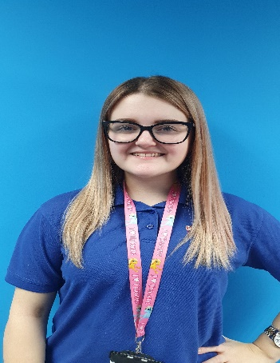

Dates for your diary

4th July – Independence Day
17th July – World emoji day
21st July – Ice cream day
30th July – International friendship day

Our Duckling Department

Throughout the summer the babies are going to enjoy having an ice cream shop in their role play area. We are looking forward to staying cool this summer by enjoying lots of water play experiences. If you haven’t already done so then can you send your child to nursery with a swimsuit, swim nappies, sun hat and sun cream which we can either keep in nursery or in your child’s bag.

Colour of the month – Pink
Song of the month – Chichiwa
Book of the month – That’s not my bee

Our Owl Department

The Owls through the summer are going to be looking forward to making their own ice cream, learning about the different flavours you can get and developing their numeracy skills by counting the scoops. Our children will be learning new vocabulary and we will be doing some junk modelling where we will be using different materials to build our own ice cream van. Throughout the summer the children will also be exploring their colours as they learn.

Colour of the month – Pink
Song of the month – Ice cream song
Story of the month – Lu Lu the tiger loves ice cream

Our Little Penguin Department

Throughout the summer the little Penguins will be having fun in their creative play area which will be set up as the ‘beach’. The children will develop their specific areas of learning, exploring numbers and counting with the stones and shells. The children will learn about their natural environment around them, they will develop their measuring skills talk about higher and lower, faster, and slower. Our little Penguins while enjoying exploring their beach area, will learn the importance of sun cream and talk about sun safety. They will learn about the different animals in the water at the beach and the different conditions of the sea, when it is safe to swim etc.

Colour of the month – Yellow
Song of the month - Beach song
Book of the month – Mole’s summer story

Our Big Penguin Department

Throughout the summer the children will be enjoying all the sunshine days. We will have pool days, trips to the park, trips to the grassy area to enjoy lots of active and physical play. We will be exploring the season of summer and continuing to prepare our older children for school.
Our role play will be set up as a beachside area where the children can enjoy some playful sand and water experiences together.

Can we please ask for spare clothing to be put into your child’s bag, swimwear/towel, also a sun hat daily so that your child can participate in these fun experiences

Colour of the month – Yellow
Song of the month – Mr golden sun

Employee of the month

We would like to congratulate Charlene Kelly from our Penguin department on being voted Employee of the month for being very supportive within her department and other departments as and when needed.
Well done Charlene
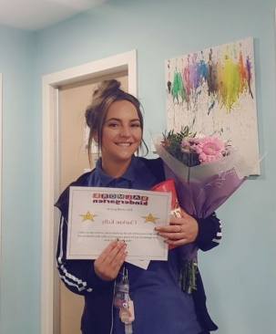

BALMORE KINDERGARTEN BIRTHDAY’S

Duckling’s | Owl’s | Small Penguin’s | Big Penguin’s
None | Travis Nicol – 16th July | Gabi Koczak – 15th July | Madison McConnell – 4th July
 | Millie Connor – 31st July | Kady Young – 29th July

