3
Balmore Kindergarten Menu – Week

 | Monday | Tuesday | Wednesday | Thursday | Friday
Lunch choice 1  (vegetarian) | Scotch Broth  With a sandwich | Scotch Broth  With a sandwich | Scotch Broth  With a sandwich | Scotch Broth  With a sandwich | Scotch Broth  With a sandwich
Lunch choice 2  Pudding | Fish Fingers, Boiled potatoes & pea’s  Fresh fruit with yoghurt | Mince and mashed potatoes with mixed veg  Fresh fruit with yoghurt | Stewed sausages with boiled potatoes  Fresh fruit with yoghurt | Chicken and Leek Pie with mixed veg  Fresh fruit with yoghurt | Lasagne and broccoli with garlic bread  Fresh fruit with yoghurt
Afternoon snack | Fresh fruit  &  Filled sandwiches | Fresh fruit  &  Pancakes | Fresh fruit  &  Crackers and cheese | Fresh fruit  &  Strawberry yoghurt cake | 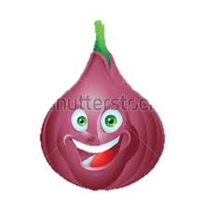  Fresh fruit  &  Rice Cakes

Fresh Milk and water are offered with all meals and snacks, Water is available throughout the day

